**Q1: - You are working on a project where you get data from third party webapi/service in XML format. You are creating charts from that data for creating a chart you need data in JSON format in order to make them compatiable you need to convert xml data into json but limitation is you can’t modify third party webservice/api you have to make Adapter that returns data in JSON by using adapter pattern.**

**UML:**

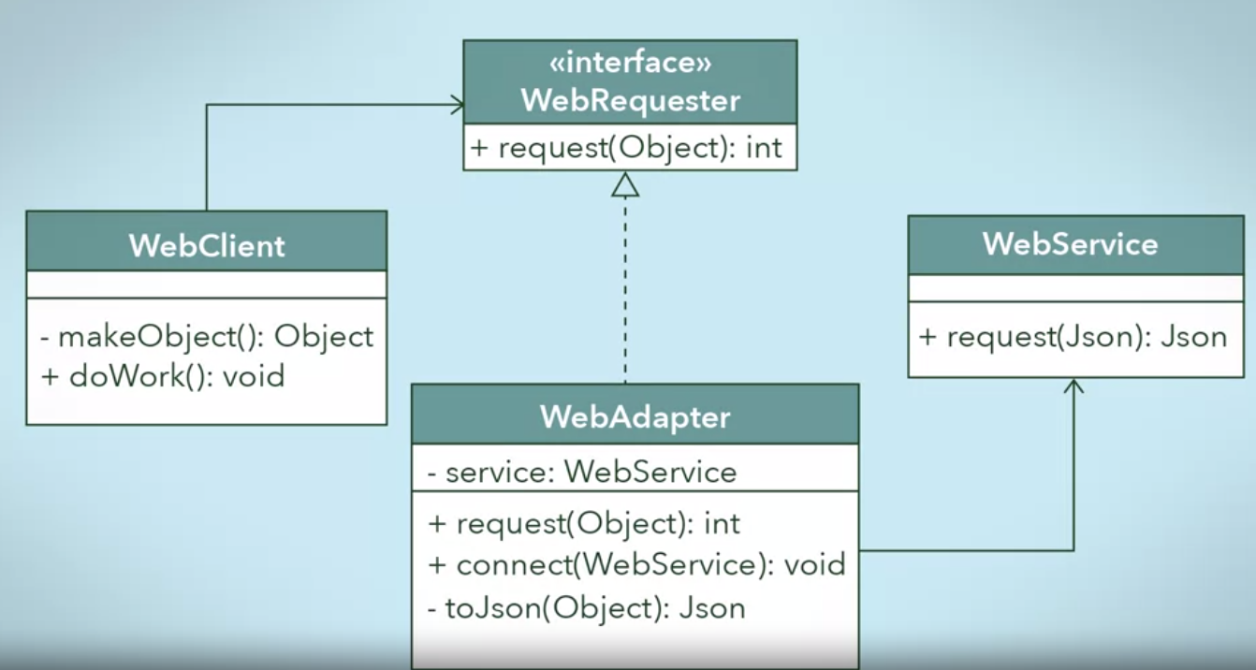

Step 1: Design the target interface

First, create the target interface that your adapter class will be implementing for your client class to use:

public interface WebRequester

{

public int request(Object);

}

Step 2: Implement the target interface with the adapter class

public class WebAdapter : WebRequester

{

private WebService service;

public void connect(WebService currentService)

{

this.service = currentService;

/* Connect to the web service */

}

public int request(Object request)

{

Json result = this.toJson(request);

Json response = service.request(result);

if (response != null)

return 100; // OK status code

return 9; // Server error status code

}

private Json toJson(Object input) { … }

}

Step 3: Send the request from the client to the adapter using the target interface

public class WebClient

{

private WebRequester webRequester;

public WebClient(WebRequester webRequester)

{

this.webRequester = webRequester;

}

private Object makeObject() { … } // Make an Object

public void doWork()

{

Object object = makeObject();

int status = webRequester.request(object);

if (status == 100)

{

Console.WriteLine("OK");

}

else

{

Console.WriteLine("Not OK");

}

return;

}

}

In the main program, the Web Adapter, the Web Service, and the Web Client needs to be instantiated. The Web Client deals with the adapter through the Web Requester interface to send a request. The Web Client should not need to know anything about the Web Service, such as its need for JSON objects. The adaptee is hidden from the client by the wrapping adapter class.

public class Program

{

public static void main(String args[])

{

String webHost = "Host: https://google.com\n\r";

WebService service = new WebService(webHost);

WebAdapter adapter = new WebAdapter();

adapter.connect(service);

WebClient client = new WebClient(adapter);

client.doWork();

}

}